Ballston Spa Community Band  Attendance Sheet (RevB)  Spring – Summer 2018 | 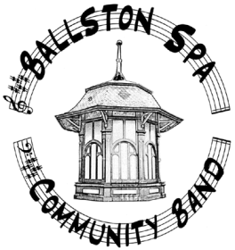

Name: ________________________ Instrument: _________________________

Folder Number: ________________Phone: ______________________________

email: _____________________________________________________________
It is important for program and rehearsal planning that we know who is available on a given date. Recently there has been only a 70% response for the completion of this form. Since these dates extend out 8 months, it is nearly impossible to exactly predict when we might experience conflicts. We DO NOT expect that this form is 100% accurate, please do your best! Thank you, Gary
Please indicate “Yes or ” if you can make the following Rehearsals / Concerts
Yes/No | Date (all 2018) | Yes/No | Date
 | March 28 |  | June 13
 | April 4 (School Break) |  | June 20
 | April 11 |  | June 27
 | April 18 |  | July 5 (Wiswall Park Concert, Ballston Spa, 6:00PM)
 | April 25 (Summit, Saratoga Springs, 7:00PM) |  | July 11
 | May 2 |  | July 13 (First Friday – Jazz Band, 7:00PM)
 | May 9 |  | July 18
 | May 16 |  | July 20 (Lake George Fest - Jazz Band)
 | May 23 |  | July 21 (Lake George Fest)
 | May 30 |  | July 25
 | June 1 (First Friday Concert, Iron Spring Park, Ballston Spa, 7:00PM) |  | August 1
 | June 3 (Beer – Dinner Fundraiser, Wolf Hollow Brewery, 6:00PM to 8:00PM) |  | August 3 (First Friday Concert)
 | June 6

NOTES:
All dates are “regular” rehearsal days, …… YELLOW Highlight are Concerts, …. GREEN Highlight are “Special Events”
If you have already completed this form and given it to Peter Miller, …. THANK YOU!!! If not, ……. Please fill it out ASAP and give to Peter.

