Ballston Spa Community Band  Call Sheet  The Summit at Saratoga  April 25th, 2018 | 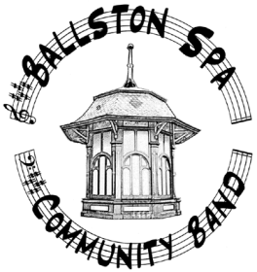

Where: The Summit at Saratoga,
1 Perry Road
Saratoga Springs, NY
When: Our scheduled start time is 7:00PM, please arrive between 6:15 and 6:40PM
Bring: Your instruments, music and a music stand
Concert Dress: BLACK on Bottom and Purple / White Band Shirt on Top
(If you do not have a band shirt, please try and get as close as possible to the Purple color.)

Equipment Team: Please arrange for enough people and vehicles to transport the necessary percussion equipment and chairs. (Vern, ….. please check with Nick)

Please meet at the high school at 5:30 to 5:45 to load equipment.

Program: (To be announced at our April 18th rehearsal)

